**COMPUTER ORGANIZATION AND ARCHITECTURE**

**COMPARING i5 and i7 PROCESSOR MOTHERBOARD**



**BY**

**FILDZA NUR SABRINA**

**L200150145**

**INFORMATICS**

**FACULTY OF COMMUNICATION AND INFORMATICS**

**­­­­­­­BRIEF**

A processor is the ‘brain’ to receive process instruction before it transfers to the other hardware. The brain on the processor can be analogous to the brain of humans. When a person wants to perform an activity, the brain will give signal first before the other body receive and resume the activity.

Today, there are many types of processors but the last 3 processors are the most widely used of INTEL products: Core i3, i5, and i7. But I will only discuss about the i5 and i7 version.

**i5 PROCESSOR**

i5 have 2 Quad Core processors on each processor. Except type I5-661 which uses Dual Core on each processor with speed 3.2 – 3.3 GHz.

Mainly i5 processor have this kind of specification:

* Support Hyper-Treading
* Consists of 2 Dual Core processor. There are also a version that consists of 2 Quad Core processor, but it doesn’t support Hyper-Treading.
* Turbo Boost maximum for automatically overclocking for about 2.4 – 3.3 GHz.
* L3 Cache 4-8 MB
* LGA Socket 1156
* Intel HD Graphics
* Maximal RAM 16 GB

The oldest version of i5 processor: Core i5-750 (1st Generation)

With the specification of:

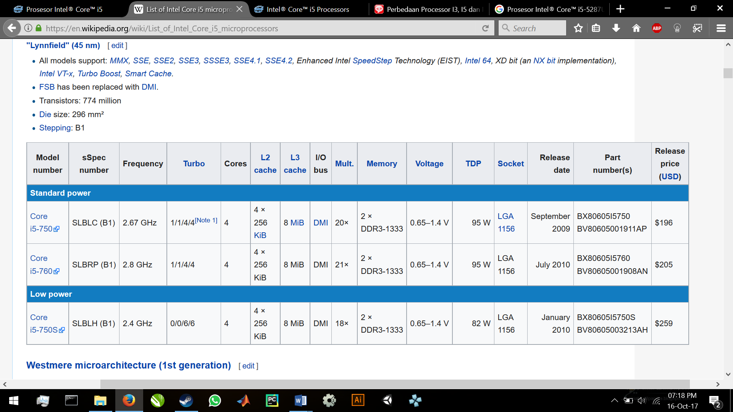

Until now, i5 processor has evolve to an amazing specs. For my opinion, nowadays i5 processor could support my daily work, task or even for entertaining. The newest version I’ve found in intel’s website is Intel® Core™ i5-8400 Processor.

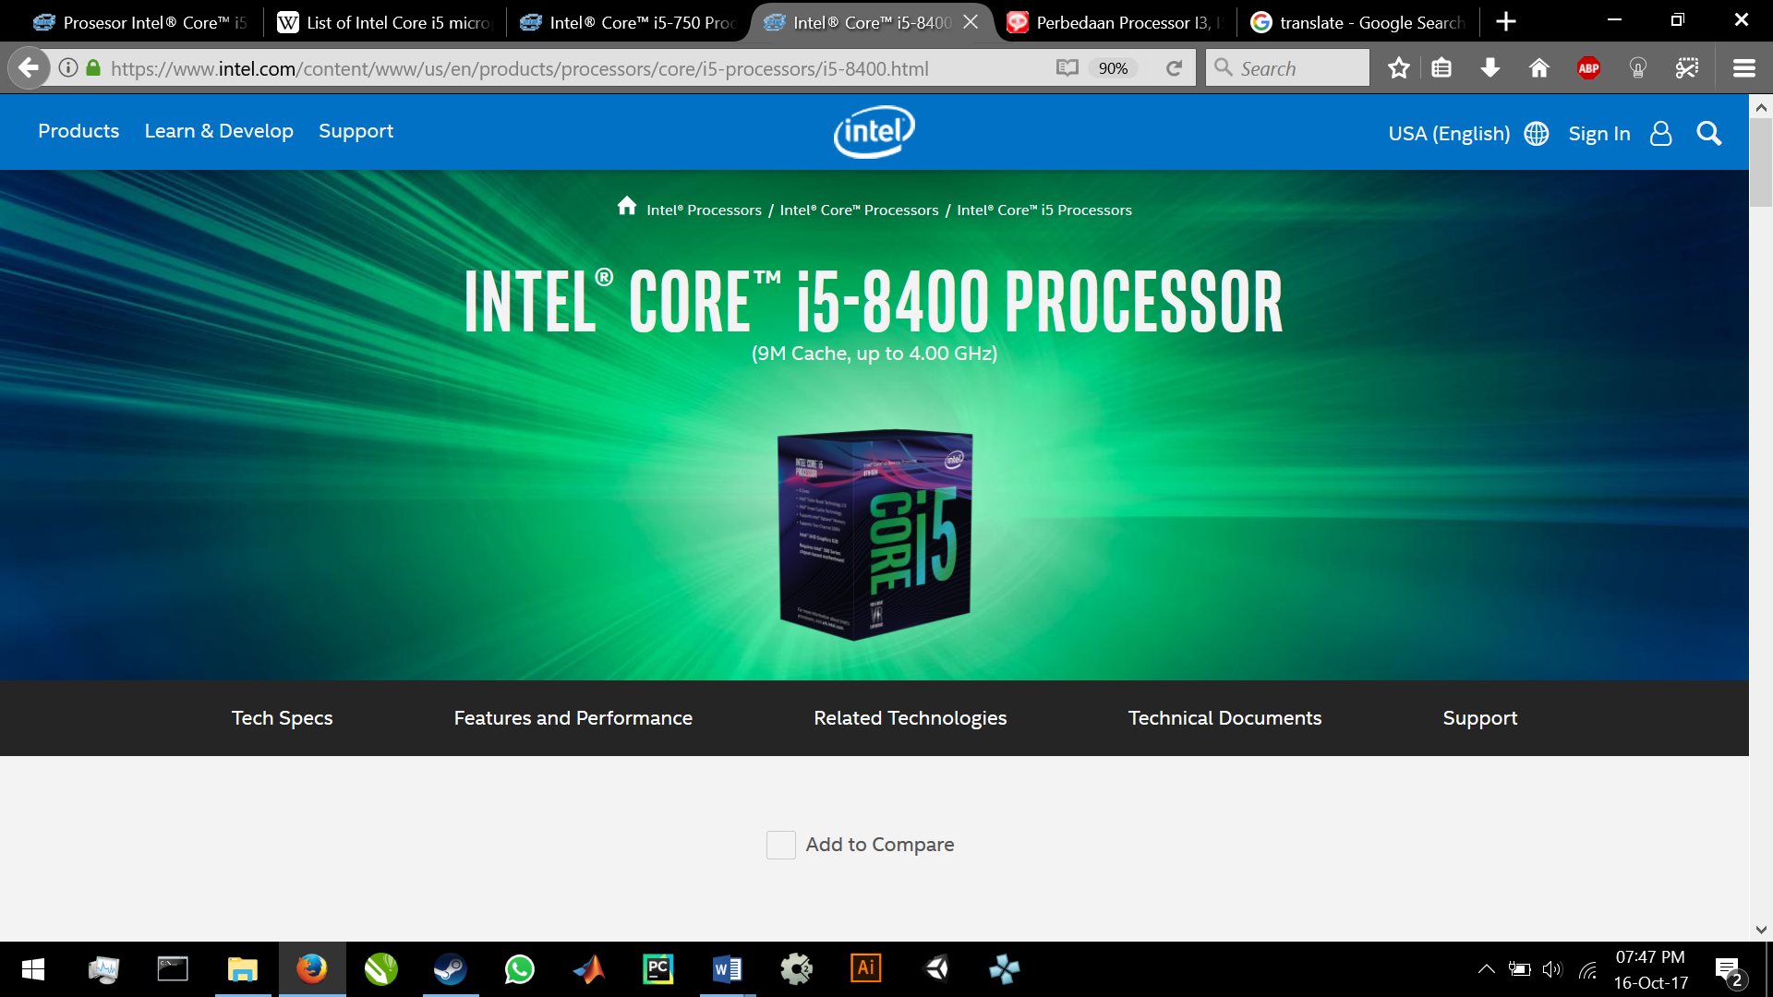

It has amazing specs such as

# of Cores : 6

# of Threads : 6

Processor Base Frequency : 2.80 GHz

Max Turbo Frequency : 4.00 GHz

Cache : 9 MB

Bus Speed : 8 GT/s DMI3

# of QPI Links : 0

TDP : 65 W

For **memory Specifications**

Max Memory Size (dependent on memory type) : 64 GB

Memory Types : DDR4-2666

Max # of Memory Channels : 2

ECC Memory Supported : No

For **Graphics Specifications**

Processor Graphics : Intel® UHD Graphics 630

Graphics Base Frequency : 350 MHz

Graphics Max Dynamic Frequency : 1.05 GHz

Graphics Video Max Memory : 64 GB

Execution Units : 23

4K Support : Yes, at 60Hz

Max Resolution (HDMI 1.4)‡ : 4096x2304@24Hz

Max Resolution (DP)‡ : 4096x2304@60Hz

Max Resolution (eDP - Integrated Flat Panel)‡ : 4096x2304@60Hz

DirectX* Support : 12

OpenGL* Support : 4.4

Intel® Quick Sync Video : Yes

Intel® InTru™ 3D Technology : Yes

Intel® Clear Video HD Technology : Yes

Intel® Clear Video Technology : Yes

# of Displays Supported ‡ : 3

Device ID : 0x3E92

And many more, you can find it at <https://www.intel.com/content/www/us/en/products/processors/core/i5-processors/i5-8400.html>

The price of the newest intel i5 8400 is Rp 2.460.000,-

**i7 PROCESSOR**

The i7 version is consists of 4 processors with Quad Core specification inside.

It supports such as:

* Hyper-Treading (Can split 4 processors into 8 processors to run heavy processes
* simultaneously such as 3D Rendering, Video Editing process. Animation etc.)
* Turbo Boost Maximum automatic overclocking ranges 1.73 GHZ to 3.33 GHZ
* L3 Cache 8 – 12 MB
* Intel QuickPath Interconnect Technology (To speed up the process of reading data up to 25.6 GB / sec)
* LGA Socket 1156
* Intel HD Graphics
* Maximum RAM 24 GB

The oldest version of i7 processor is Core i7 – 920 with this specification:

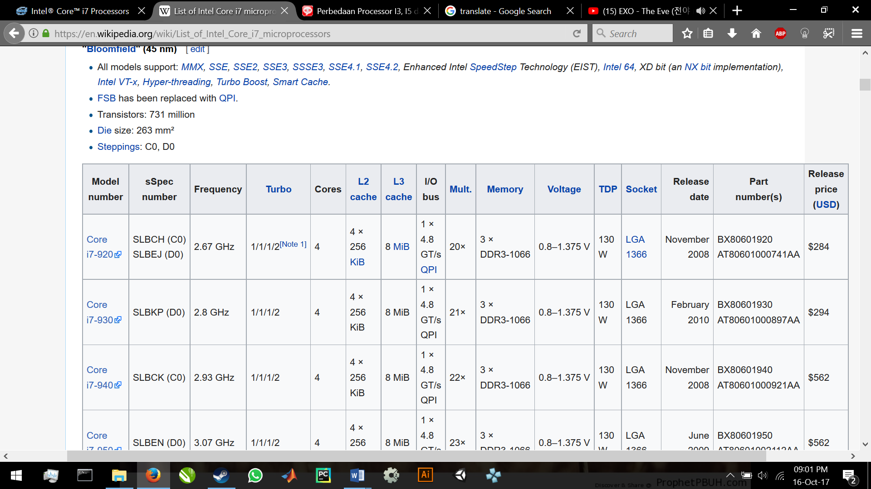

The i7 is the highest level of Intel Core before the X-series (or people says it as i9 processor) popped up in second quartal on 2017. Of course, i7 could do a better performance than i5 such as office application, but nowadays people especially uses i7 for gaming, combined with maximum RAM and VGA Graphic card.

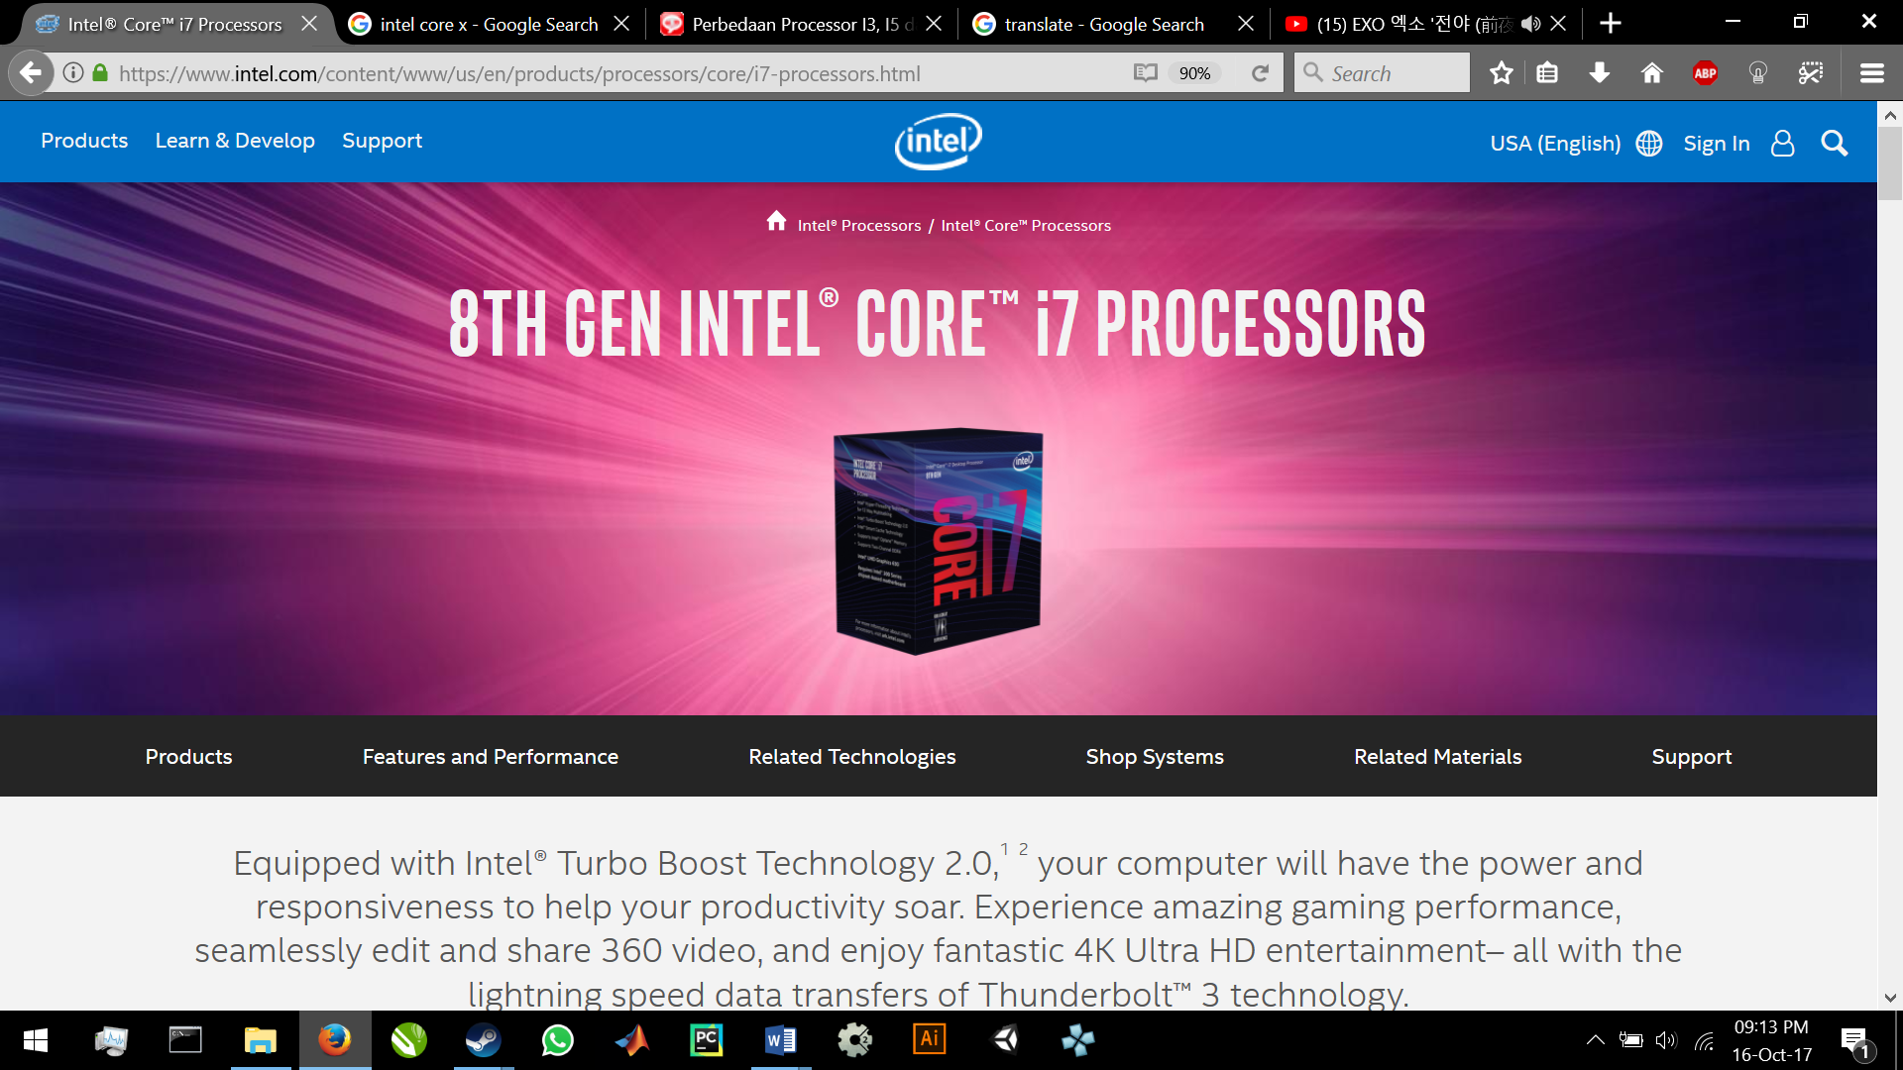

This is the newest version of i7 with this specification:

**Performance**

# of Cores : 6

# of Threads : 12

Processor Base Frequency : 3.20 GHz

Max Turbo Frequency : 4.60 GHz

Cache : 12 MB

Bus Speed : 8 GT/s DMI3

TDP : 65 W

**Memory Specifications**

Max Memory Size (dependent on memory type) : 64 GB

Memory Types : DDR4-2666

Max # of Memory Channels : 2

ECC Memory Supported ‡ : No

**Graphics Specifications**

Processor Graphics ‡ : Intel® UHD Graphics 630

Graphics Base Frequency : 350 MHz

Graphics Max Dynamic Frequency : 1.20 GHz

Graphics Video Max Memory : 64 GB

Execution Units : 24

4K Support : Yes, at 60Hz

Max Resolution (HDMI 1.4)‡ : 4096x2304@24Hz

Max Resolution (DP)‡ : 4096x2304@60Hz

Max Resolution (eDP - Integrated Flat Panel)‡ : 4096x2304@60Hz

DirectX* Support : 12

OpenGL* Support : 4.5

Intel® Quick Sync Video : Yes

Intel® InTru™ 3D Technology : Yes

Intel® Clear Video HD Technology : Yes

Intel® Clear Video Technology : Yes

# of Displays Supported ‡ : 3

Device ID : 0x3E92

Complete specification can be found here

<https://www.intel.com/content/www/us/en/products/processors/core/i7-processors/i7-8700.html>

And the price is Rp 6.700.000,-